Course Work 2

Nile University

Scientific Computing

Ahmed Samr (1910032)

Youssef Ansara (1910063)

Amr Al Sayed (202000199)

### General Form

$$\frac{dy}{dt}=f\left(t,y\right)$$

$$y_{n+1}=y_{n}+h\sum_{i=1}^{s}{b_{i}k_{i}}$$

For explicit methods:

$$k_{i}=f\left(t_{n}+c_{i}h,y_{n}+h\sum_{j=1}^{i-1}{a_{ij}k_{j}}\right)$$

For implicit methods:

$$k_{i}=f\left(t_{n}+c_{i}h,y_{n}+h\sum_{j=1}^{s}{a_{ij}k_{j}}\right)$$

Coefficients:

$$b_{i}=\left[\begin{matrix}b_{1} & b_{2} & ⋯ & b_{s-1} & b_{s}\end{matrix}\right]$$

$$c_{i}=\left[\begin{matrix}c_{1} & c_{2} & ⋯ & c_{s-1} & c_{s}\end{matrix}\right]$$

$$\left(\begin{matrix}a_{11} & a_{12} & ⋯ & a_{1\left(s-1\right)} & a_{1s} \\ a_{21} & a_{22} & ⋯ & a_{2\left(s-1\right)} & a_{2s} \\ ⋮ & ⋮ & ⋱ & ⋮ & ⋮ \\ a_{\left(s-1\right)1} & a_{\left(s-1\right)2} & ⋯ & a_{\left(s-1\right)\left(s-1\right)} & a_{\left(s-1\right)s} \\ a_{s1} & a_{s2} & ⋯ & a_{s\left(s-1\right)} & a_{ss}\end{matrix}\right)$$

### Forward Euler (1st Order)

$$b=\left[\begin{matrix}1\end{matrix}\right]$$

$$c=\left[\begin{matrix}0\end{matrix}\right]$$

$$a=\left(\begin{matrix}0\end{matrix}\right)$$

$$y_{n+1}=y_{n}+k_{1}h$$

$$k_{1}=f\left(t_{n},y_{n}\right)$$

### Explicit Midpoint (2nd Order)

$$b=\left[\begin{matrix}0 & 1\end{matrix}\right]$$

$$c=\left[\begin{matrix}0 & \frac{1}{2}\end{matrix}\right]$$

$$a=\left(\begin{matrix}0 & 0 \\ \frac{1}{2} & 0\end{matrix}\right)$$

$$y_{n+1}=y_{n}+k_{2}h$$

$$k_{1}=f\left(t_{n},y_{n}\right)$$

$$k_{2}= f\left(t_{n}+\frac{1}{2}h,y_{n}+\frac{1}{2}k_{1}h\right)$$

### Heun (2nd Order)

$$b=\left[\begin{matrix}\frac{1}{2} & \frac{1}{2}\end{matrix}\right]$$

$$c=\left[\begin{matrix}0 & 1\end{matrix}\right]$$

$$a=\left(\begin{matrix}0 & 0 \\ 1 & 0\end{matrix}\right)$$

$$y_{n+1}=y_{n}+\frac{1}{2}\left(k_{1}+k_{2}\right)h$$

$$k_{1}=f\left(t_{n},y_{n}\right)$$

$$k_{2}= f\left(t_{n}+h,y_{n}+k_{1}h\right)$$

### Fourth-Order Runge–Kutta (4th order)

$$b=\left[\begin{matrix}\frac{1}{6} & \frac{1}{3} & \frac{1}{3} & \frac{1}{6}\end{matrix}\right]$$

$$c=\left[\begin{matrix}0 & \frac{1}{2} & \frac{1}{2} & 1\end{matrix}\right]$$

$$a=\left(\begin{matrix}0 & 0 & 0 & 0 \\ \frac{1}{2} & 0 & 0 & 0 \\ 0 & \frac{1}{2} & 0 & 0 \\ 0 & 0 & 1 & 0\end{matrix}\right)$$

$$y_{n+1}=y_{n}+\frac{1}{6}\left(k_{1}+2k_{2}+2k_{3}+k_{4}\right)h$$

$$k_{1}=f\left(t_{n},y_{n}\right)$$

$$k_{2}=f\left(t_{n}+\frac{1}{2}h,y_{n}+\frac{1}{2}k_{1}h\right)$$

$$k_{3}=f\left(t_{n}+\frac{1}{2}h,y_{n}+\frac{1}{2}k_{2}h\right)$$

$$k_{4}=f\left(t_{n}+h,y_{n}+k_{3}h\right)$$

### Fifth-Order Butcher’s Runge-Kutta (6th order)

$$b=\left[\begin{matrix}\frac{7}{90} & 0 & \frac{16}{45} & \frac{2}{15} & \frac{16}{45} & \frac{7}{90}\end{matrix}\right]$$

$$c=\left[\begin{matrix}0 & \frac{1}{4} & \frac{1}{4} & \frac{1}{2} & \frac{3}{4} & 1\end{matrix}\right]$$

$$a=\left(\begin{matrix}0 & 0 & 0 & 0 & 0 & 0 \\ \frac{1}{4} & 0 & 0 & 0 & 0 & 0 \\ \frac{1}{8} & \frac{1}{8} & 0 & 0 & 0 & 0 \\ 0 & -\frac{1}{2} & 1 & 0 & 0 & 0 \\ \frac{3}{16} & 0 & 0 & \frac{9}{16} & 0 & 0 \\ -\frac{3}{7} & \frac{2}{7} & \frac{12}{7} & \frac{12}{7} & \frac{8}{7} & 0\end{matrix}\right)$$

$$y_{n+1}=y_{n}+\frac{1}{90}\left(7k_{1}+32k_{3}+12k_{4}+32k_{5}+7k_{6}\right)h$$

$$k_{1}=f\left(t_{n},y_{n}\right)$$

$$k_{2}=f\left(t_{n}+\frac{1}{4}h,y_{n}+\frac{1}{4}k_{1}h\right)$$

$$k_{3}=f\left(t_{n}+\frac{1}{4}h,y_{n}+\left(\frac{1}{8}k_{1}+\frac{1}{8}k_{2}\right)h\right)$$

$$k_{4}=f\left(t_{n}+\frac{1}{2}h,y_{n}+\left(-\frac{1}{2}k_{2}+k_{3}\right)h\right)$$

$$k_{5}=f\left(t_{n}+\frac{3}{4}h,y_{n}+\left(\frac{3}{16}k_{1}+\frac{9}{16}k_{4}\right)h\right)$$

$$k_{6}=f\left(t_{n}+h,y_{n}+\left(-\frac{3}{7}k_{1}+\frac{2}{7}k_{2}+\frac{12}{7}k_{3}+\frac{12}{7}k_{4}+\frac{8}{7}k_{5}\right)h\right)$$

### Comparison of Integration methods

All of the integration methods are compared with these parameters $$World Damping Factor=0.04$$

$$Hook^{'}s Spring Constant=5$$

$$Spring Damping=0.1$$

$$Timestep=0.01$$

### Test 1

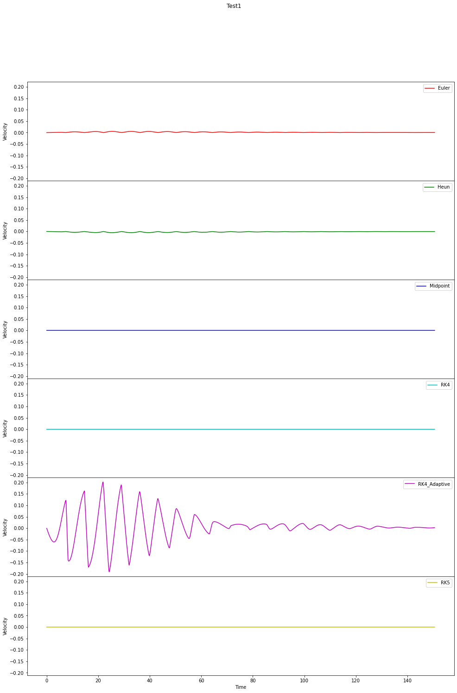Figure Comparison of Average particle positions using Test 1

Test 2 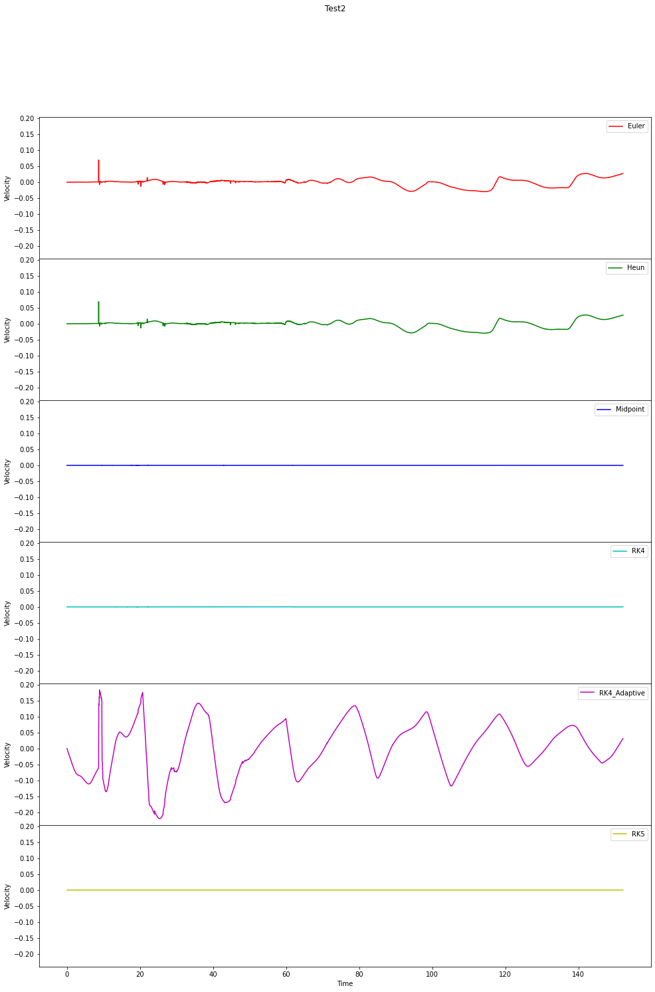

Figure Comparison of Average particle positions using Test 2

### Test 3

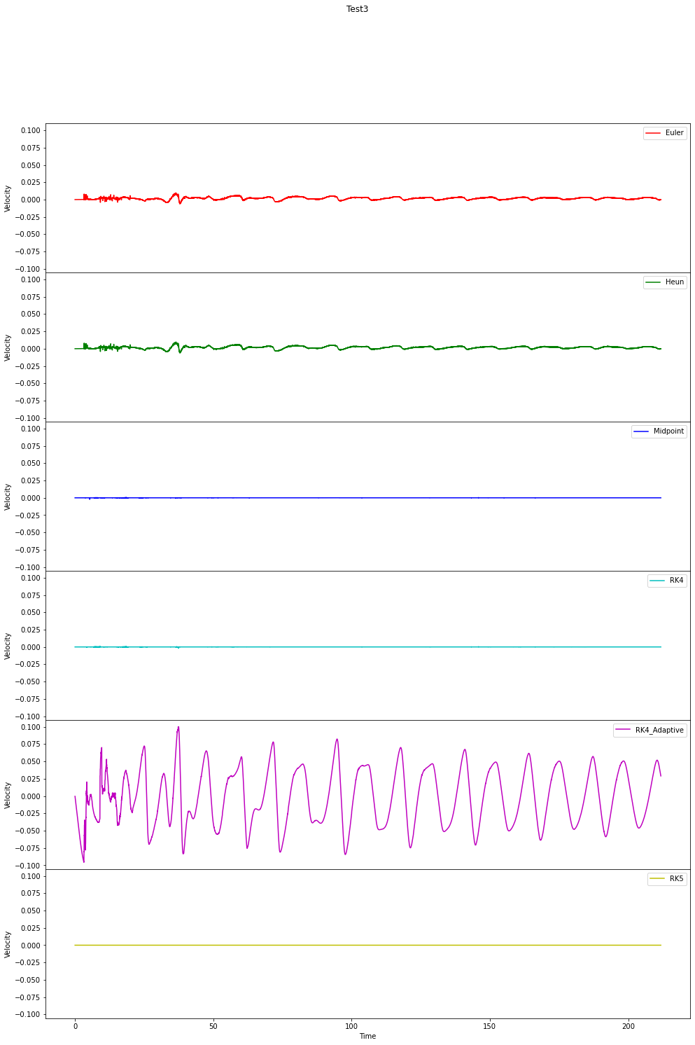

Figure Comparison of Average particle positions using Test 3

All comparisons were made with Fifth Runge-Kutta as the base.

So, using the default parameters, all integrators behaved very similarly except for Adaptive Fourth Order Runge-Kutta method which fluctuates wildly away from the result of Fifth Order Runge-Kutta. Euler & Midpoint methods also show some deviation away from the Fifth Order Runge-Kutta result across all tests.

This means that for our next test we will **NOT** be decreasing the step size as the simulation is already very similar and a smaller test size will not show any differences. Also only Test 3 will be used as it is the most intensive one and has many collisions and external factors that strain the system.

Let’s take these parameters. They’re the default parameters but with 10 times the step size

$$World Damping Factor=0.04$$

$$Hook^{'}s Spring Constant=5$$

$$Spring Damping=0.1$$

$$Timestep=0.1$$

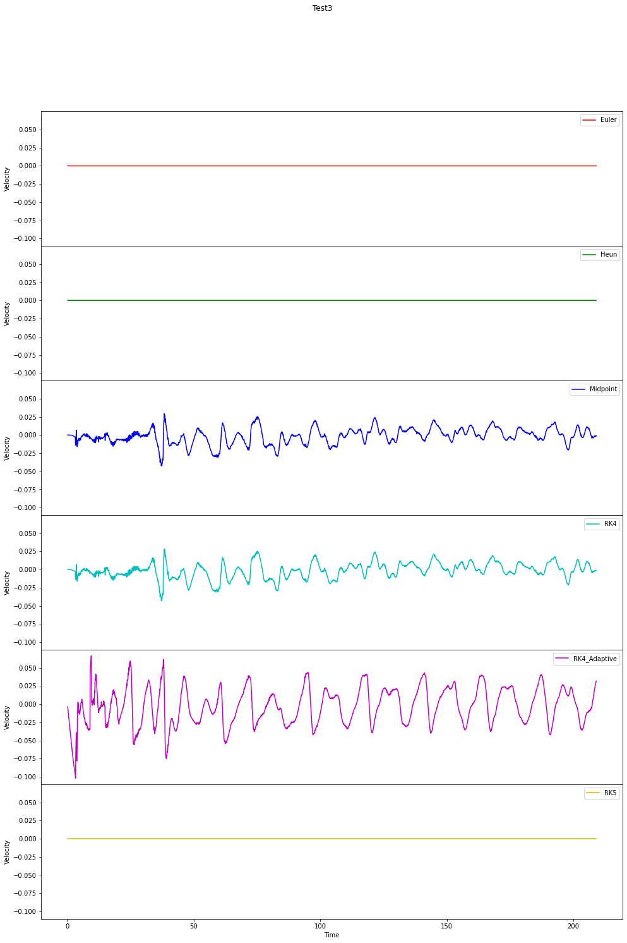

Figure Comparison of Integration methods with an increased step size

This result is very strange and is extremely unexpected. Euler matching almost exactly the Fifth Order Runge Kutta is not a sensible result. I failed to see the reason for this.

To test the limits of the system, we will be quadrupling the default Spring Constant to 20 which simulates very stiff springs between vertices.

$$World Damping Factor=0.04$$

$$Hook^{'}s Spring Constant=20$$

$$Spring Damping=0.1$$

$$Timestep=0.01$$

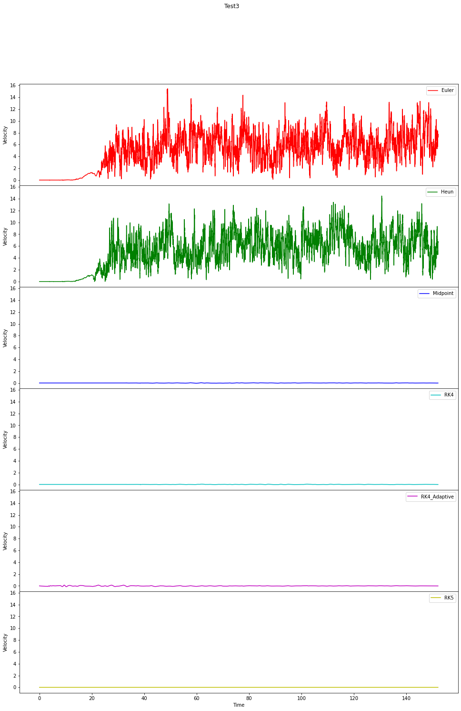

Figure Comparison of Integration method when the Spring Constant is 20

Both Euler & Huen start out as very similar to Fifth Order Runge-Kutta but as the collisions increase the system just shakes vigorously in a way that is nothing like a cloth.